**Protein structure identification**

**Step 1 BlstP**

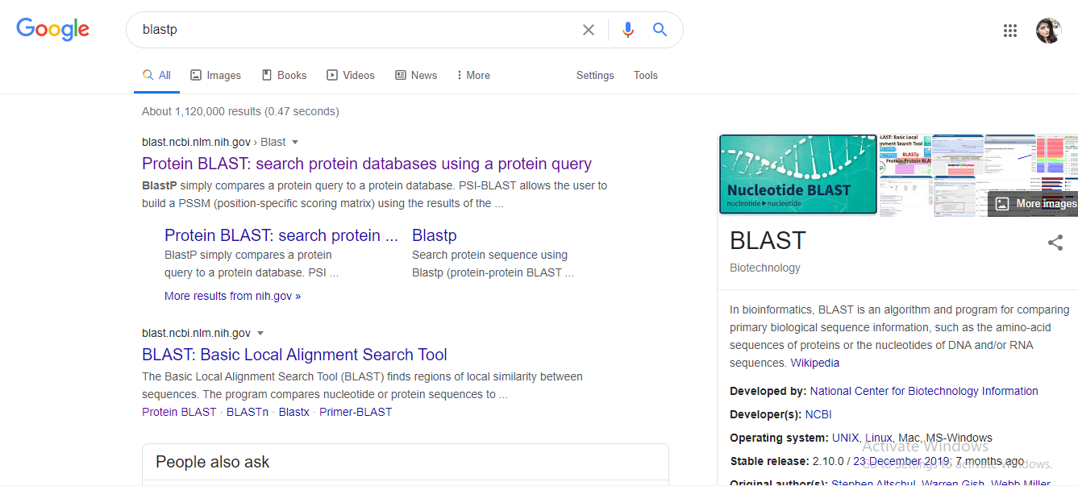

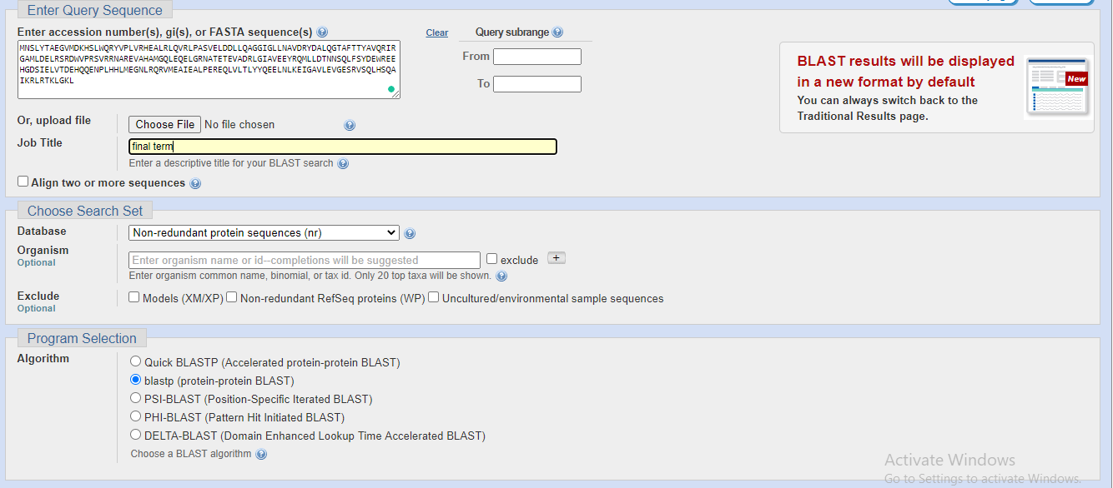

Results of blastp

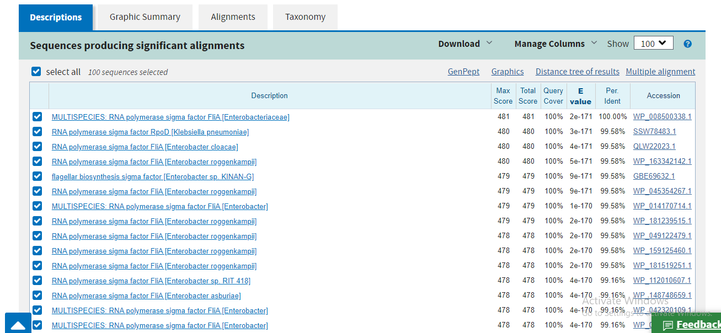

Top 1 is selected

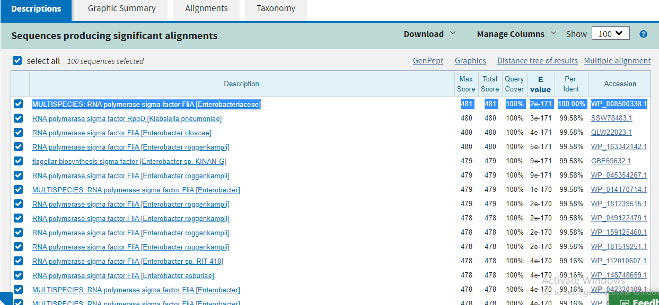

After clicking on top 1 sequence

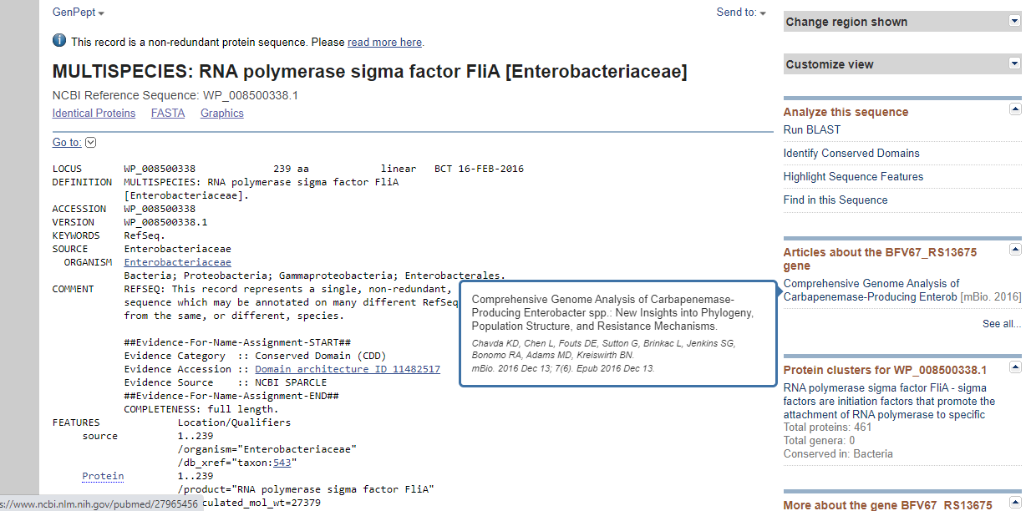

ACCESSION No is selected for further analysis

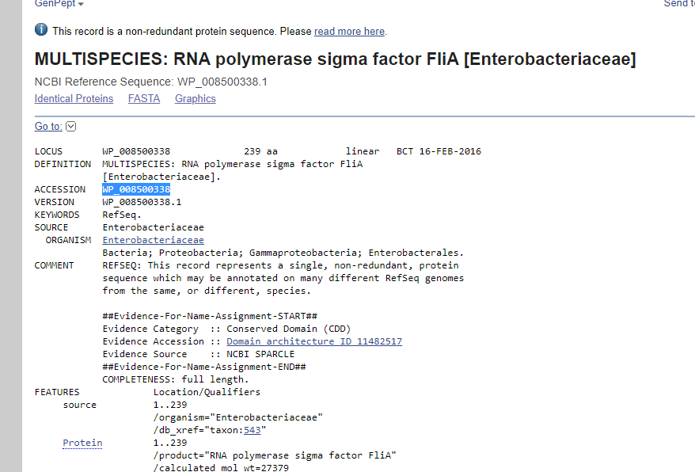

Go to uniprotkb

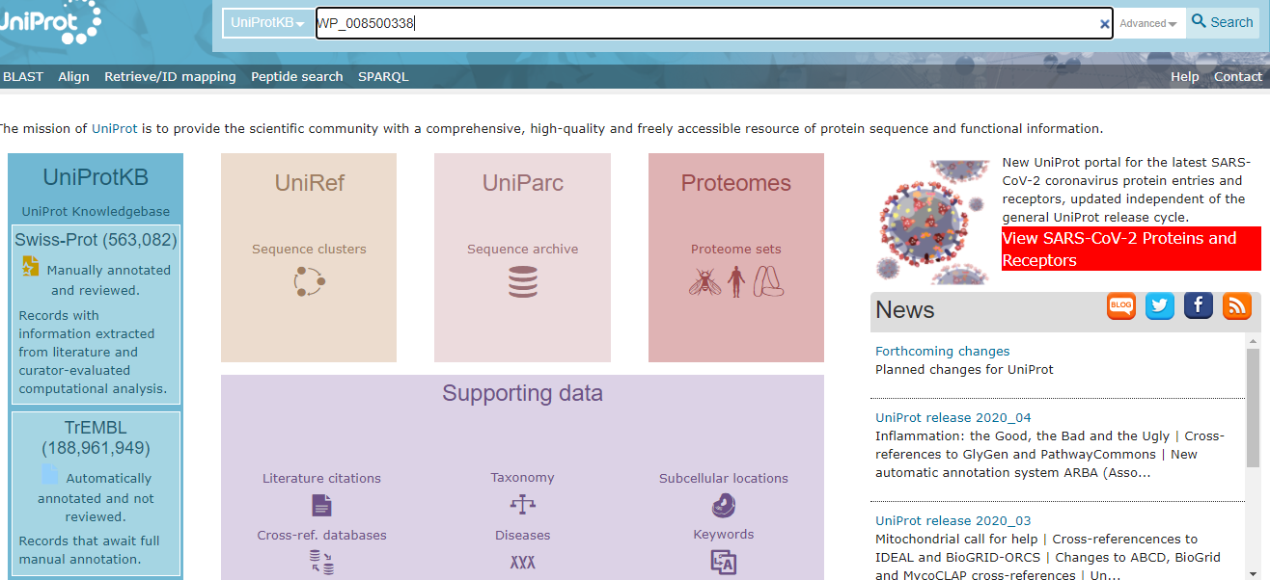

**After Pasting the accession no in bar as shown above**

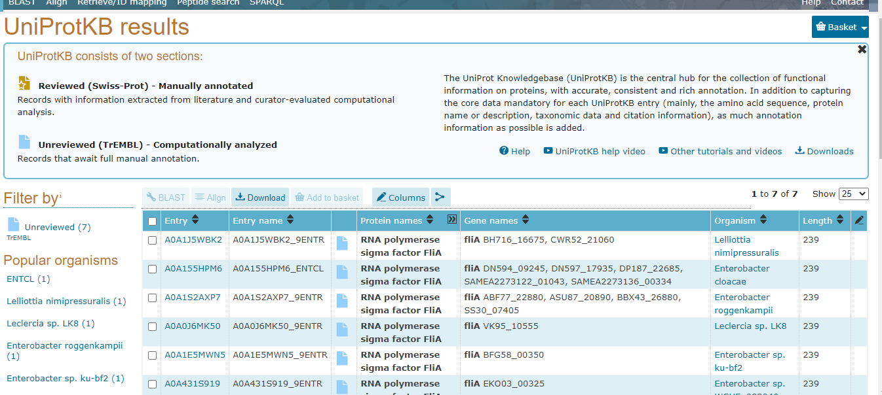

**Click on first 1**

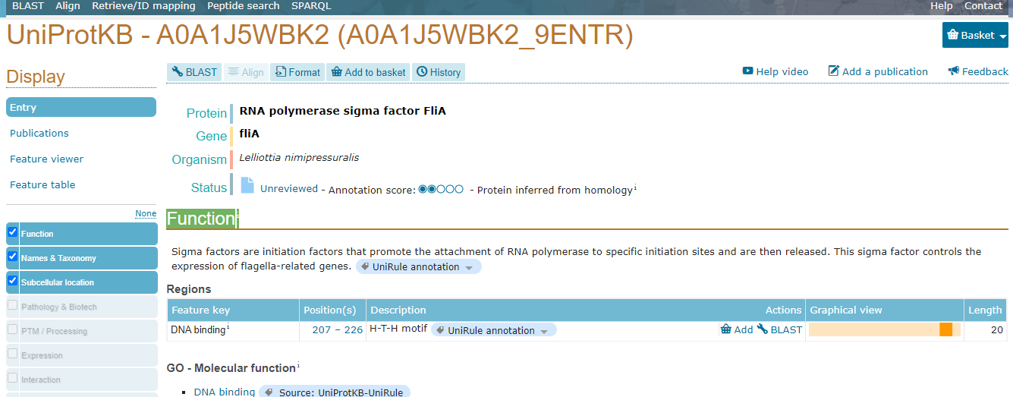

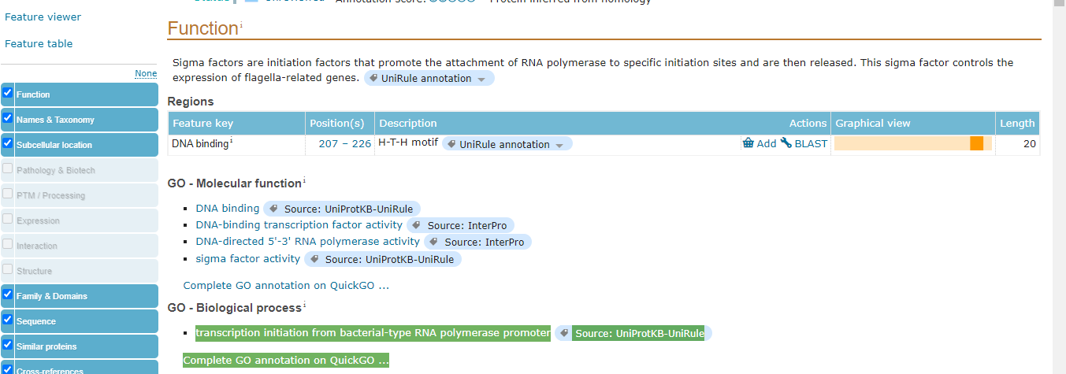

Functioni

Sigma factors are initiation factors that promote the attachment of RNA polymerase to specific initiation sites and are then released. This sigma factor controls the expression of flagella-related genes.UniRule annotation

#### GO - Molecular function**i**

* [DNA binding](https://www.ebi.ac.uk/QuickGO/term/GO:0003677) Source: UniProtKB-UniRule
* [DNA-binding transcription factor activity](https://www.ebi.ac.uk/QuickGO/term/GO:0003700) Source: InterPro
* [DNA-directed 5'-3' RNA polymerase activity](https://www.ebi.ac.uk/QuickGO/term/GO:0003899) Source: InterPro
* [sigma factor activity](https://www.ebi.ac.uk/QuickGO/term/GO:0016987) Source: UniProtKB-UniRule

[Complete GO annotation on QuickGO ...](https://www.ebi.ac.uk/QuickGO/annotations?geneProductId=A0A1J5WBK2)

#### GO - Biological process**i**

* [transcription initiation from bacterial-type RNA polymerase promoter](https://www.ebi.ac.uk/QuickGO/term/GO:0001123) Source: UniProtKB-UniRule

[Complete GO annotation on QuickGO ...](https://www.ebi.ac.uk/QuickGO/annotations?geneProductId=A0A1J5WBK2)

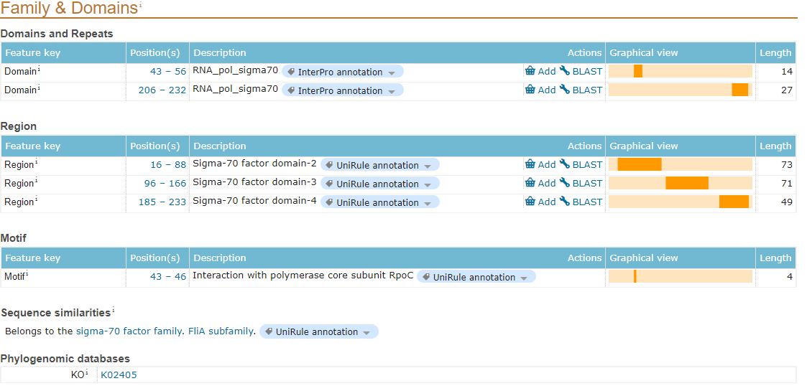

Protein structure prediction using 3dpro

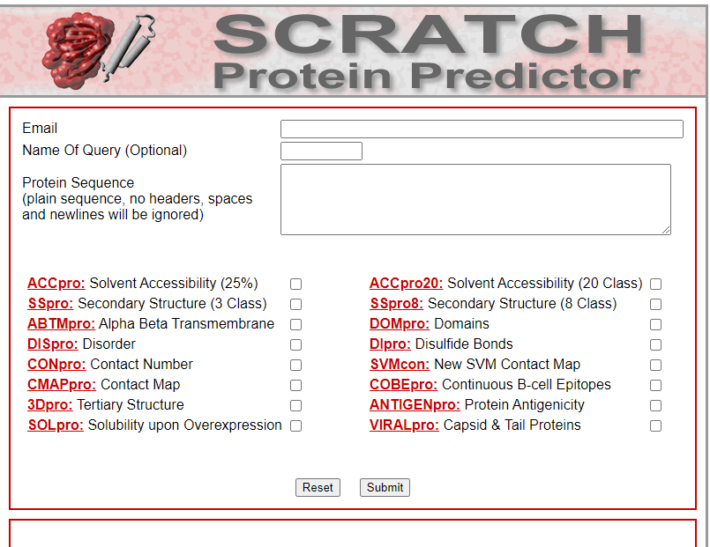

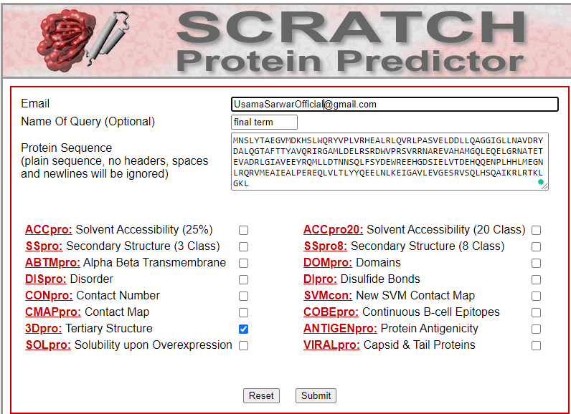

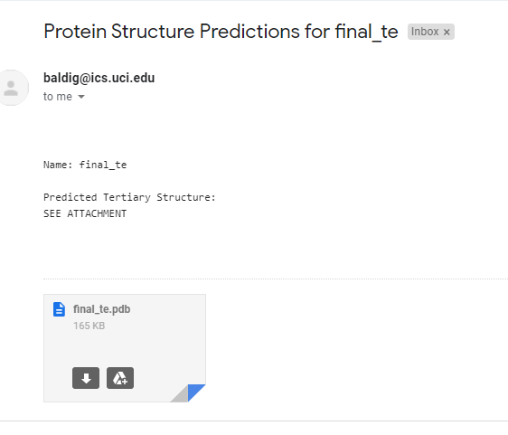

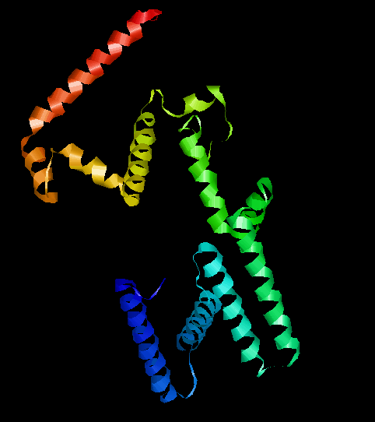

Protein-protein interaction using STRING Database

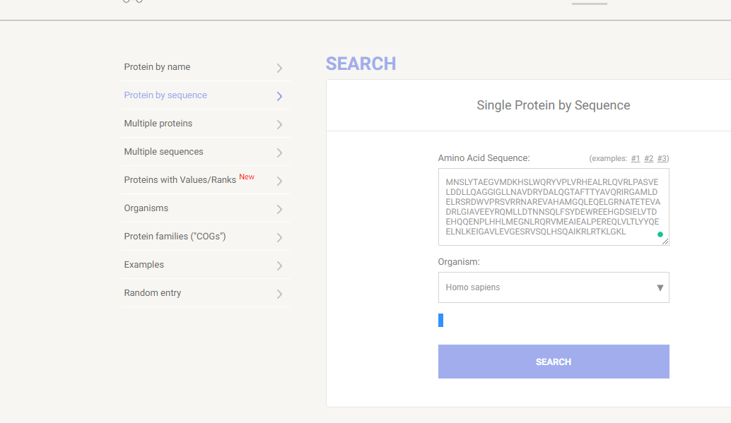

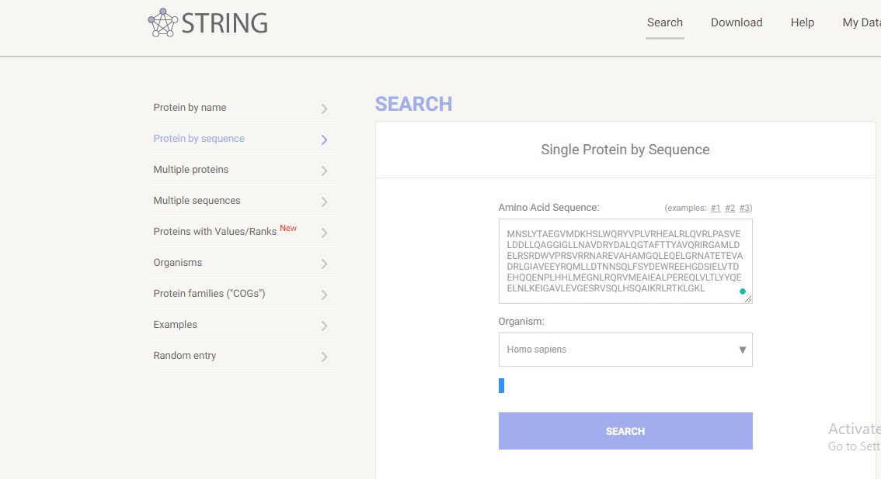

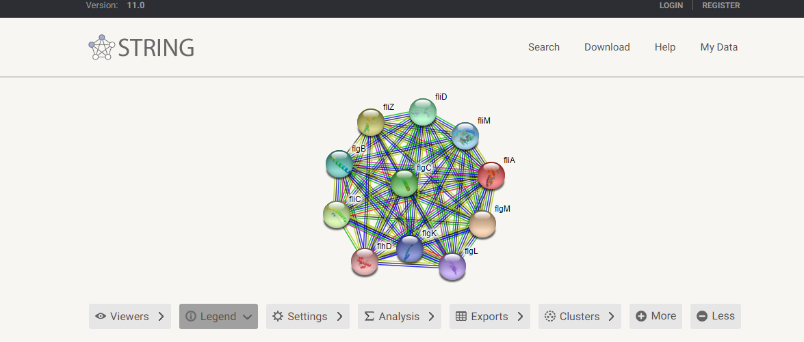

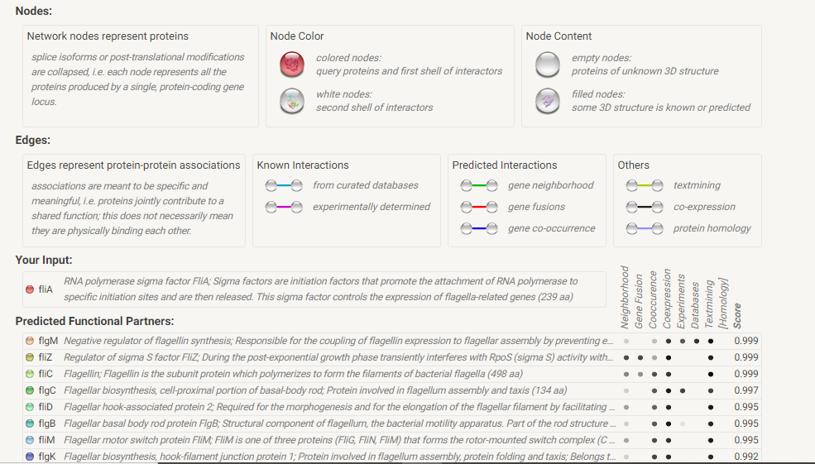

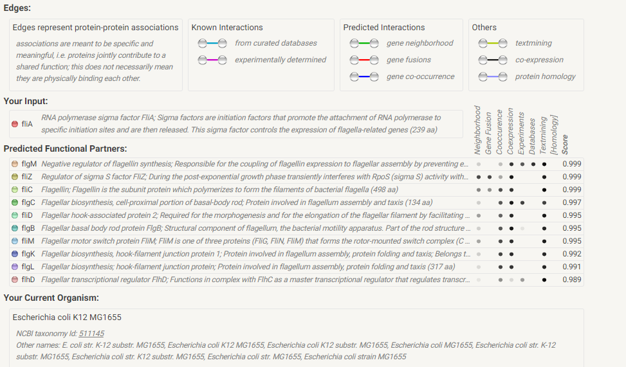

TASK 2

Reverse translation

